Introduction: Patch size has been shown to have a significant effect on species richness not habitat configuration (Hanski, 2015), though it is argued test should be done on individual species not communities as the species withing a community will have different habitat requirements. This is seen in generalists who are better able to survive in smaller patch sizes (Andrén, 1994), it has also been shown that habitat suitability is more important than special arrangement especially when suitable habitat is greater the 30%.

Modelling Habitat fragmentation can be done in many ways including: Three-level hierarchical maps(Collingham & Huntley, 2000), Random destruction using special system(Bascompte & Sole, 1996), LSF, software to emulate raster map(Hargis et al., 1998) and the use of R packages like LevGen which grows habitat around focal point(Chetcuti et al., 2020, 2021) and AnimalHabitatNetwork which uses model networks(He et al., 2021).

Method:

Model run for 5 seed burn in and 5 seeds fragmentation, for the first parameters were set No.Species = 95, Interaction distance= 1, Dispersal distance= 1, Intraspecific competition=-0.1, for the second run the Dispersal distance (DD) and Interaction distance(ID)were changed to 4 different combination (DD=1 ID=1, DD=1.5 ID=1.5, DD=1 ID=1.5, DD=1.5 ID=1). Runs were done on landscapes generated using Amalgamation and Random(percentage cover 0-1 in 0.1 increments) and Raster generated (0.3-0.8).

Results:

The mean total population and mean species richness were but into Dataframes with landscape generation type and percentage over. Linear models were run to test if land generation or percentage cover had a significant effect on mean total population and species richness, for both mean total population and species richness only percentage cover showed significance.

Figure 1 shows the mean total population over percentage cover for the three landscape generation types separately and Figure 2 shows the combined mean total population over percentage cover data of all landscape generation types (Multiple R-squared: 0.9648, Adjusted R-squared: 0.9647, F-statistic: 6553 on 10 and 2389 DF, p-value: < 2.2e-16), for mean species richness (Multiple R-squared: 0.09816, Adjusted R-squared: 0.09438, F-statistic: 26 on 10 and 2389 DF, p-value: < 2.2e-16).

Figure 3 shows the mean species richness over percentage cover for the three landscape generation types separately and Figure 4 shows the combined mean species richness over percentage over data of all landscape generation types. Whereas landscape generation was as significant and had a considerably weaker relationship, for mean total population (Multiple R-squared: 0.0002316, Adjusted R-squared: -0.0006026, F-statistic: 0.2776 on 2 and 2397 DF, p-value: 0.7576), for mean species richness (Multiple R-squared: 0.005368, Adjusted R-squared: 0.004538, F-statistic: 6.468 on 2 and 2397 DF, p-value: 0.001579).

Figure 5 shows the effects of interaction distance and dispersal distance on species richness, when either distance was increased to 1.5, allowing for dispersal or interactions in 8 direction, species richness is shown to decrease. Interaction distance had a larger effect as shown be Figure 5 C and D, C shows lower species richness when dispersal distance is set to 1 and interaction distance is set to 1.5 the D with dispersal distance is set to 1.5 and interaction distance is set to 1.

Outliers in figures 2 and 5 show the total population and species richness are the beginning of the fragmentation runs which suffers a large drop after fragmentation and stopped immigration from the species pool and then as slower drop there after.

Conclusion:

As the landscape generation didn’t show a significant relationship for the final run to answer the main question the amalgamation landscape generation will be used. As it more closely resembles realistic habitat fragmentation then the random generation but allows more control the using Raster files.

Due to the loss in species richness and increased computational time the final run will be done with dispersal and interaction distances set to 1 disallowing diagonal movement.

Figure 1: Three box plots of Mean total population size over percentage cover

Figure 2: Combined Mean total population size over percentage cover data for all landscape generation methods

Figure 4: Combined Mean Species richness over percentage cover data for all landscape generation methods

Figure 3: Three box plots of Mean Species richness size over percentage cover

B

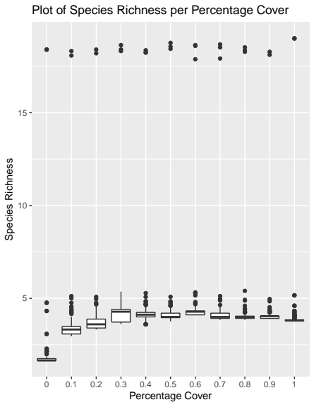

A

A

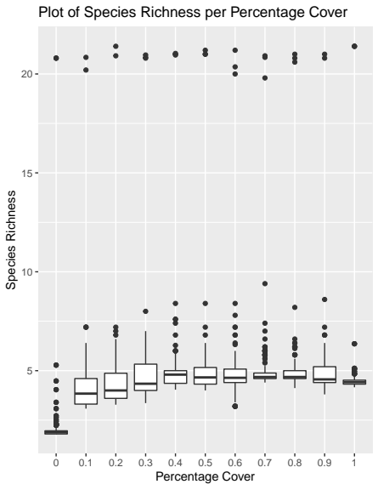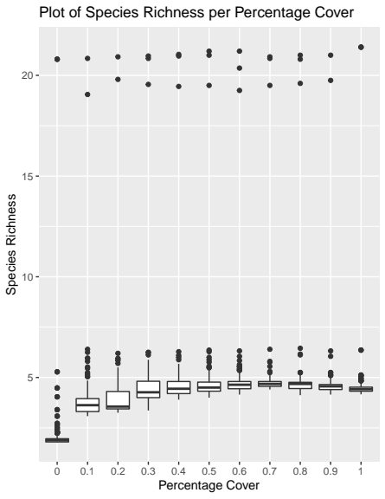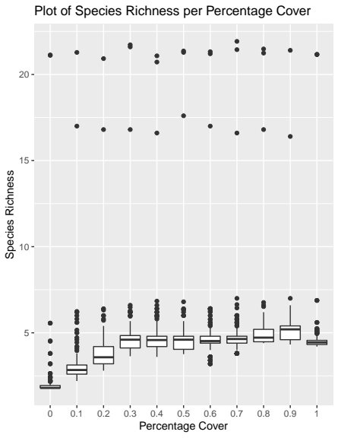

Figure5: plots of conbined data at different dispersal and interation distances. A:1,1 B:1.5,1.5 C:1,1.5 D:1.5,1

C

D